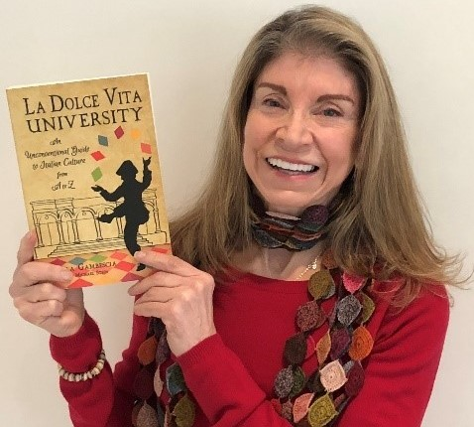

CARLA GAMBESCIA is a food and travel writer, lecturer, restaurateur, entrepreneur, and co-creator of the Giro del Gelato cycling tour (winner of Outside magazine’s Best Trip in Western Europe). She has traveled every region of “the Boot” on foot or by bicycle.

Charmingly illustrated, La Dolce University brings Italy to life with wit, exuberance, and joy – a celebration of why we love Italy. Even the most sophisticated Italophile will discover dazzling new facts and illuminating new insights in these pages. ~Travelers’ Tales

Postcards From The Boot photoblog:
https://postcardsfromtheboot.com/

La Dolce Vita “U” website:
https://www.ladolcevitau.com/

To purchase La Dolce University through Amazon:
https://www.amazon.com/Dolce-Vita-University-2nd-Unconventional/dp/1609521986/

